Test Rig Manual





**Table of Contents**

1. Introduction 1

2. Hardware Setup 2

2.1 Overview 2

2.2 myRIO 2

2.2.1 MXP Port A Pinouts 4

2.2.2 MXP Port B Pinouts 4

2.2.3 MSP Connector Pinouts (Port C) 5

2.3 Load Cell Amplifier 6

2.4 Current Sensor 6

2.5 Voltage Divider Circuit (Voltmeter) 6

2.6 Light Sensor Circuit 6

3. Software 7

3.1 Overview 7

3.2 Setup 7

3.3 Main 7

# Introduction

This test rig manual covers the hardware setup (including the wiring) and the usage section of the test rig.

# Hardware Setup

## 2.1 Overview

Looking at Figure 1, we can see that the PC connects to three myRIO’s and the Dynamixel motors. These hardware are connected to the PC via USB connections. Within the myRIO, the PC accesses the myRIO’s FPGA boards for readout values for each component connected to the myRIO (except PWM out, where the PC sends an output instead). The left and right motors are powered using an external power supply.

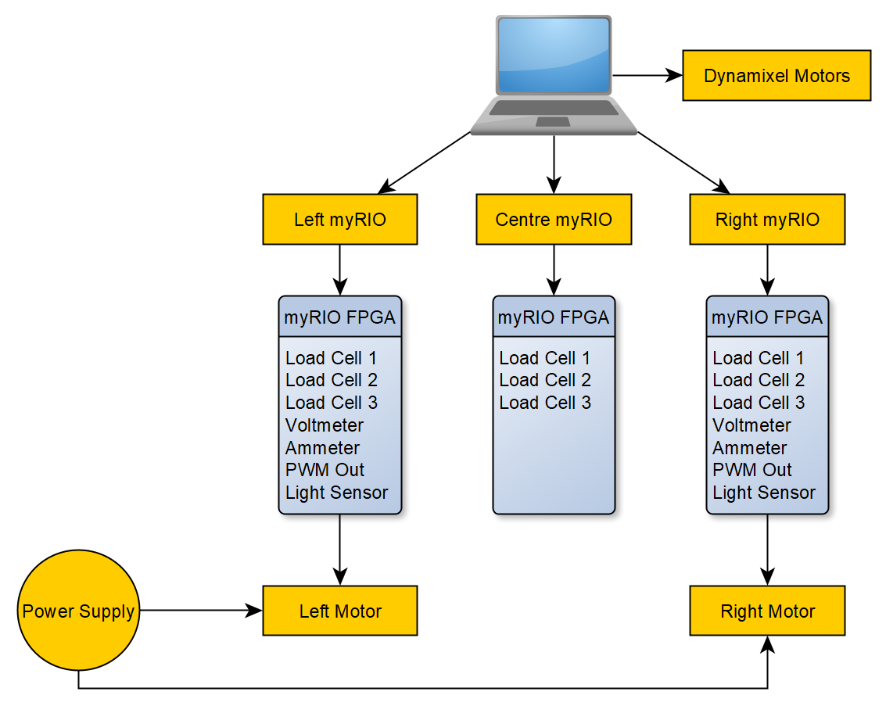

Figure Current Rig Setup

## 2.2 myRIO

The NI myRIO is a microcontroller and an FPGA board all in one package. For the test rig, we do not really need the microcontroller, as the PC will do all the processing work, but the FPGA board is what is useful. The FPGA board provides a proper real-time interface to the hardware that the PC cannot do especially when its operating system is Windows. The myRIO has two MXP connectors shown in Figure 2 and one MSP connector shown in Figure 3. The rest of this subsection will detail the pinouts for the myRIO

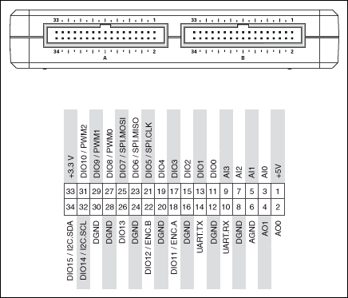

Figure myRIO MXP connectors and their pinouts

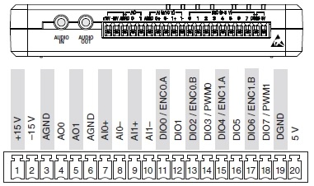

Figure myRIO MSP connector and its pinout

### 2.2.1 MXP Port A Pinouts

The following table provides a mapping for the myRIO to components. Please note pins 3, 6, 27 and 28 are only used for the left and right myRIO’s. Except for the wires used in pins 27 and 28 which use female-to-male wires, all other wires use female-to-female wires.

Table MXP Connector Port A Pinouts

|  |  |  |  |
| --- | --- | --- | --- |
| **From** | **To** | **Colour** | **Function** |
| Pin 1 | VCC of Load Cell Amplifiers (via parallel branch) | Red | Provides power to the amplifiers |
| Pin 8 | GND of Load Cell Amplifiers (via parallel branch) | Black | Provides the reference line to the amplifiers |
| Pin 11 | DAT of Load Cell 1 | Blue | Provides bit by bit data on this line |
| Pin 13 | CLK of Load Cell 1 | White | Provides the sync clock in which to receive the data |
| Pin 15 | DAT of Load Cell 2 | Blue | Provides bit by bit data on this line |
| Pin 17 | CLK of Load Cell 2 | White | Provides the sync clock in which to receive the data |
| Pin 19 | DAT of Load Cell 3 | Blue | Provides bit by bit data on this line |
| Pin 21 | CLK of Load Cell 3 | White | Provides the sync clock in which to receive the data |
| Pin 33 | VDD of Load Cell 1 (via parallel branch) | Yellow | Provides power line for measurement |
| Pin 3 | IOut of KR Sense 90A | Green | Measures the current |
| Pin 6 | GND of KR Sense 90A | Black | Provides a reference line |
| Pin 27 | Signal line of motor PWM input | Yellow | Sends a PWM signal to the motor |
| Pin 28 | Ground line of motor PWM input | Black | Sends a reference line with the PWM signal to the motor |

### 2.2.2 MXP Port B Pinouts

The following table provides a mapping for the myRIO to components. Please note that this port is only used for the left and right myRIO’s. The connection for pin 6 uses a female-to-female wire. Pins 3 and 6 use a female-to-multiple-female wires.

Table MXP Connector Port B Pinouts

|  |  |  |  |
| --- | --- | --- | --- |
| **From** | **To** | **Colour** | **Function** |
| Pin 1 | 5V lines of light sensor circuit | Yellow | Provides power to the light sensor |
| Pin 3 | Non-ground end of the measurement resistor | Green | Measures the voltage across the measurement resistor of the light sensor |
| Pin 6 | Ground lines of light sensor circuit | White | Provides a reference line to the light sensor |

### 2.2.3 MSP Connector Pinouts (Port C)

The following table provides a mapping for the myRIO to components. Please note that this port is only used for the left and right myRIO’s. The wires that are used to connect pins 6 and 7 to the voltage divider circuit just use plain wires. Also note that there is a resistor that is used to connect Pin 6 and Pin 8 together. If Pin 6 and Pin 8 aren’t connected by a resistor, then there will be a significant drift in the voltmeter readings.

|  |  |  |  |
| --- | --- | --- | --- |
| **From** | **To** | **Colour** | **Function** |
| Pin 6 (AGND) | Ground end of the measurement resistor in the voltage divider circuit | Black | Provides a reference line to the light sensor |
| Pin 7 (AI0+) | Non-ground end of the measurement resistor in the voltage divider circuit | Yellow | Provides a scaled down voltage measurement |
| Pin 8 (AI0-) | Pin 6 (AGND) using a 10k resistor | 10k resistor | Ensures that the AIO- end is virtually earthed. 10k resistor is used to dissipate any charge buildup that occurs due to a floating pin. |

## 2.3 Load Cell Amplifier

As of writing this manual, the load cell amplifier used was the HX-711. The wiring to the myRIO can be found in 2.2.1 MXP Port A Pinouts. The wiring to the load cell should be self-explanatory as the colour of the wires from the load cell amplifier should match that of the HX-711’s colour pinouts, except that the yellow pin is not used.

If using more HX-711 amplifiers, one should solder male pin headers onto the board, and connect with the myRIO using female-to-female wires.

If using more load cells, one should note the order of the colour of the pins of the HX-711 and arrange the load cell wires accordingly. Crimp a female pin header off the wires.

## 2.4 Current Sensor

Wiring, how it works, and the direction of current flow

## 2.5 Voltage Divider Circuit (Voltmeter)

Wiring, how it works, and the circuit schematic

## 2.6 Light Sensor Circuit

Wiring, how it works, and the circuit schematic

# Software

## 3.1 Overview

## 3.2 Setup

## 3.3 Main Program